create database CodingChallenge;

use CodingChallengeTest;

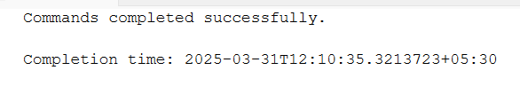

CREATE TABLE Crime (

CrimeID INT PRIMARY KEY,

IncidentType VARCHAR(255),

IncidentDate DATE,

Location VARCHAR(255),

Description TEXT,

Status VARCHAR(100)

);

CREATE TABLE Victim (

VictimID INT PRIMARY KEY,

CrimeID INT,

Name VARCHAR(255),

ContactInfo VARCHAR(255),

Injuries VARCHAR(255),

FOREIGN KEY (CrimeID) REFERENCES Crime(CrimeID)

);

CREATE TABLE Suspect (

SuspectID INT PRIMARY KEY,

CrimeID INT,

Name VARCHAR(255),

Description TEXT,

CriminalHistory TEXT,

FOREIGN KEY (CrimeID) REFERENCES Crime(CrimeID)

);

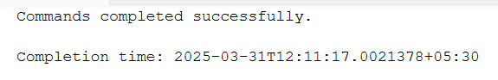

INSERT INTO Crime (CrimeID, IncidentType, IncidentDate, Location, Description, Status)

VALUES

(1, 'Robbery', '2023-09-15', '123 Main St, Cityville', 'Armed robbery at a convenience store', 'Open'),

(2, 'Homicide', '2023-09-20', '456 Elm St, Townsville', 'Investigation into a murder case', 'Under

Investigation'),

(3, 'Theft', '2023-09-10', '789 Oak St, Villagetown', 'Shoplifting incident at a mall', 'Closed');

INSERT INTO Victim (VictimID, CrimeID, Name, ContactInfo, Injuries)

VALUES

(1, 1, 'John Doe', 'johndoe@example.com', 'Minor injuries'),

(2, 2, 'Jane Smith', 'janesmith@example.com', 'Deceased'),

(3, 3, 'Alice Johnson', 'alicejohnson@example.com', 'None');

INSERT INTO Suspect (SuspectID, CrimeID, Name, Description, CriminalHistory)

VALUES

(1, 1, 'Robber 1', 'Armed and masked robber', 'Previous robbery convictions'),

(2, 2, 'Unknown', 'Investigation ongoing', NULL),

(3, 3, 'Suspect 1', 'Shoplifting suspect', 'Prior shoplifting arrests');

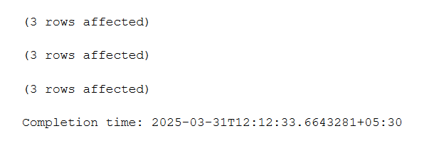

**--1. Select all open incidents.**

select * from Crime where status='Open';



**--2. Find the total number of incidents.**

select count(*) as [No of incidents] from Crime;

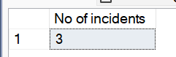

**--3. List all unique incident types.**

select distinct IncidentType as [Distinct Incidents] from Crime;

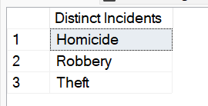

**--4. Retrieve incidents that occurred between '2023-09-01' and '2023-09-10'.**

select IncidentType as [Incident],IncidentDate as [Date] from Crime where IncidentDate between '2023-09-01' and '2023-09-10';

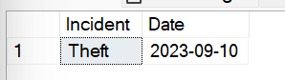

**--5. List persons involved in incidents in descending order of age.**

ALTER TABLE Victim

ADD Age INT;

ALTER TABLE Suspect

ADD Age INT;

**-- Update Victim Ages**

UPDATE Victim

SET Age = 35 WHERE VictimID = 1;

UPDATE Victim

SET Age = 28 WHERE VictimID = 2;

UPDATE Victim

SET Age = 40 WHERE VictimID = 3;

**-- Update Suspect Ages**

UPDATE Suspect

SET Age = 30 WHERE SuspectID = 1;

UPDATE Suspect

SET Age = 45 WHERE SuspectID = 2;

UPDATE Suspect

SET Age = 25 WHERE SuspectID = 3;



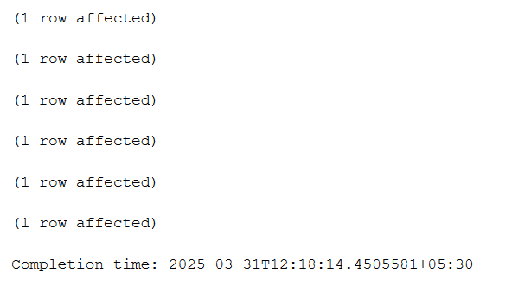

select name,Age as [Victim age] from Victim union select name,Age

from Suspect order by Age desc;

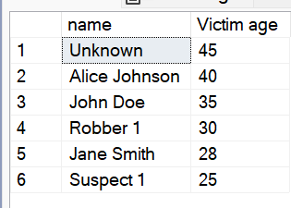

**--6. Find the average age of persons involved in incidents.**

select avg(Age) as [Average Age] from (select Age from Victim union all select age from Suspect) as Allpersons;

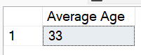

**--7. List incident types and their counts, only for open cases.**

select distinct IncidentType, count(*) as [Incident Count] from Crime where Status='Open' group by IncidentType;

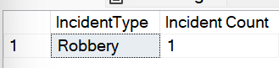

**--8. Find persons with names containing 'Doe'.**

select name as[Names]from Victim where name like '%doe%' union select name from Suspect where name like '%doe%';

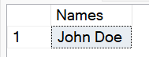

**--9. Retrieve the names of persons involved in open cases and closed cases.**

select v.Name as [Names] from Victim v join crime c on v.VictimID=c.CrimeID where c.Status in ('Open','Closed')

union

select s.Name from Suspect s join crime c on s.SuspectID=c.CrimeID where c.Status in ('Open','Closed');

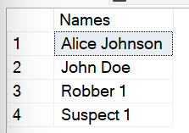

**--10. List incident types where there are persons aged 30 or 35 involved.**

Select distinct c.IncidentType as [Incident Type] from crime c join Victim v on c.CrimeID=v.CrimeID where v.Age in (30,35)

union

Select distinct c.IncidentType from crime c join Suspect s on c.CrimeID=s.CrimeID where s.Age in (30,35);

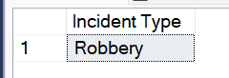

**--11. Find persons involved in incidents of the same type as 'Robbery'.**

select v.Name as [Person] from crime c join Victim v on c.CrimeID=v.CrimeID where c.IncidentType='Robbery'

union

select s.Name from crime c join Suspect s on c.CrimeID=s.CrimeID where c.IncidentType='Robbery';

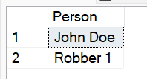

**--12. List incident types with more than one open case.**

**-- Inserting multiple open cases for the same incident type**

insert into Crime (CrimeID, IncidentType, IncidentDate, Location, Description, Status)

values

(6, 'Robbery', '2023-10-01', '500 King St, Metro City', 'Bank robbery', 'Open'),

(7, 'Robbery', '2023-10-02', '600 Queen St, Metro City', 'Jewelry store heist', 'Open'),

(8, 'Burglary', '2023-10-03', '700 Maple St, Townsville', 'Apartment break-in', 'Open'),

(9, 'Burglary', '2023-10-04', '800 Pine St, Cityville', 'Office burglary', 'Open');

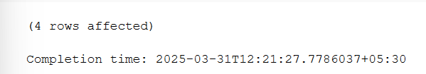

select IncidentType,Count(*) from Crime where Status='Open' group by IncidentType having COUNT(*)>1;

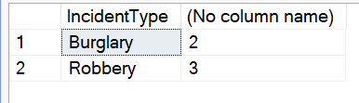

--13. List all incidents with suspects whose names also appear as victims in other incidents.

**-- insert a new crime incident**

insert into Crime (CrimeID, IncidentType, IncidentDate, Location, Description, Status)

values (4, 'Burglary', '2023-09-25', '101 Pine St, Metro City', 'House break-in reported', 'Open');

**-- insert a victim who will also be a suspect in another incident**

insert into Victim (VictimID, CrimeID, Name, ContactInfo, Injuries)

values (4, 4, 'Michael Brown', 'michael@example.com', 'Minor injuries');

**-- insert a new suspect with the same name as a victim in another incident**

insert into Crime (CrimeID, IncidentType, IncidentDate, Location, Description, Status)

values (5, 'Assault', '2023-09-26', '222 Birch St, Metro City', 'Street fight reported', 'Under Investigation');

insert into Suspect (SuspectID, CrimeID, Name, Description, CriminalHistory)

values (4, 5, 'Michael Brown', 'Involved in a street fight', 'Prior altercation reports');



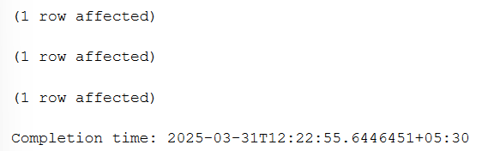

select DISTINCT C.CrimeID, C.IncidentType, C.IncidentDate, C.Location, C.Status

from Crime C

JOIN Suspect S ON C.CrimeID = S.CrimeID

where S.Name IN (select V.Name from Victim V);



**--14. Retrieve all incidents along with victim and suspect details.**

select c.CrimeID, c.IncidentType, c.IncidentDate, c.Location, c.Description, c.Status,

v.VictimID, v.Name as [Victim Name], v.ContactInfo as [Victim Contact], v.Injuries as [Victim Injuries],

s.SuspectID, s.Name as [Suspect Name], s.Description as [Suspect Description], s.CriminalHistory from Crime c

left join Victim v on c.CrimeID=v.CrimeID left join Suspect s on c.CrimeID=s.SuspectID;

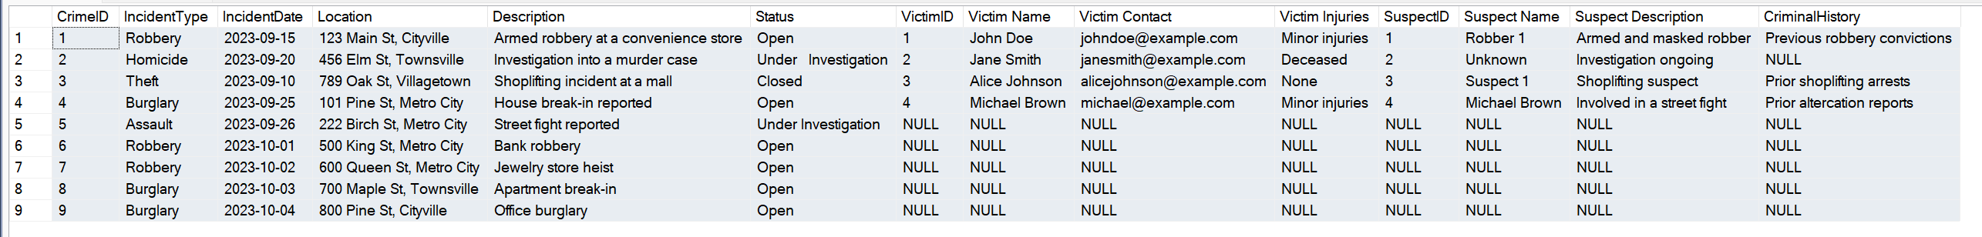

**--15. Find incidents where the suspect is older than any victim.**

select c.CrimeID, c.IncidentType, c.IncidentDate, c.Location, c.Description, c.Status from Crime c

join Suspect s on c.CrimeID=s.CrimeID where s.Age>All(select v.Age from Victim v where v.CrimeID=c.CrimeID);

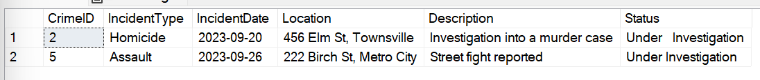

**--16. Find suspects involved in multiple incidents:**

**-- Adding a suspect linked to multiple crimes**

insert into Suspect (SuspectID, CrimeID, Name, Description, CriminalHistory)

values

(5, 1, 'John Doe', 'Repeat offender involved in multiple incidents', 'Previous theft and robbery cases'),

(6, 3, 'John Doe', 'Suspected in another theft case', 'Prior shoplifting and theft history'),

(7, 2, 'Michael Brown', 'Involved in multiple violent cases', 'Assault and prior arrests'),

(8, 5, 'Michael Brown', 'Suspected in another crime', 'Repeat offender');

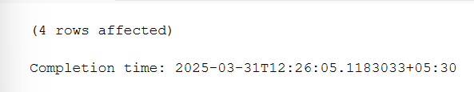

select s.Name , Count(s.CrimeId) as [Incident Count] from Suspect s group by s.Name having count(s.CrimeId)>1;

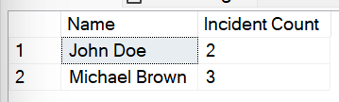

**--17. List incidents with no suspects involved.**

select c.CrimeID, c.IncidentType, c.IncidentDate, c.Location, c.Description, c.Status

from Crime c

left join Suspect s on c.CrimeID = s.CrimeID

where s.CrimeID is null;

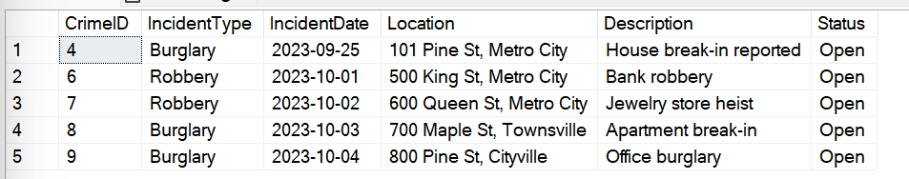

**--18. List all cases where at least one incident is of type 'Homicide' and all other incidents are of type 'Robbery'.**

**-- Case 1: Valid case with one Homicide and other Robberies**

insert into Crime (CrimeID, IncidentType, IncidentDate, Location, Description, Status)

values (11, 'Homicide', '2023-09-20', '111 Cedar St, Townsville', 'Murder investigation', 'Open'),

(12, 'Robbery', '2023-09-21', '112 Cedar St, Townsville', 'Bank Robbery', 'Open'),

(13, 'Robbery', '2023-09-22', '113 Cedar St, Townsville', 'ATM Theft', 'Open');

**-- Case 2: Invalid case (should not appear in output) because it has a 'Burglary'**

insert into Crime (CrimeID, IncidentType, IncidentDate, Location, Description, Status)

values (14, 'Homicide', '2023-09-25', '200 Birch St, Metro City', 'Another murder case', 'Under Investigation'),

(15, 'Burglary', '2023-09-26', '201 Birch St, Metro City', 'Office break-in', 'Open');

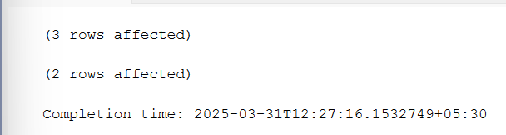

select distinct c1.CrimeID, c1.IncidentType, c1.IncidentDate, c1.Location,

CAST(c1.Description as VARCHAR(MAX)) as Description, c1.Status

from Crime c1

where c1.IncidentType = 'Homicide'

and not exists (select 1 from Crime c2 where c2.Location like c1.Location and c2.IncidentType not in ('Homicide', 'Robbery'));

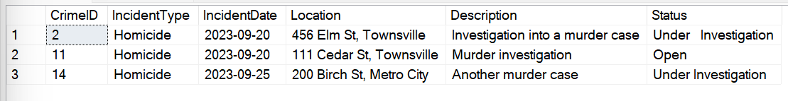

**--19. Retrieve a list of all incidents and the associated suspects, showing suspects for each incident, or 'No Suspect' if there are none.**

select c.CrimeID, c.IncidentType, c.IncidentDate, c.Location, c.Description, c.Status,

COALESCE(s.Name, 'No Suspect') as Suspect_Name

from Crime c

left join Suspect s on C.CrimeID = S.CrimeID;

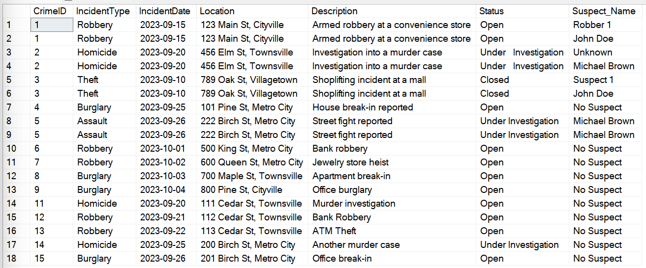

**--20. List all suspects who have been involved in incidents with incident types 'Robbery' or 'Assault'**

select s.SuspectID, s.Name, s.Description, s.CriminalHistory

from Suspect s

join Crime c on s.CrimeID = c.CrimeID

where c.IncidentType in ('Robbery', 'Assault');

